Design and Development of LegalQuestor: An AI-Powered Retrieval-Augmented and Large Language Models based Conversational Platform for Legal Guidance
Divya Verma Vani Rana Uma Yadav
Dept. of CSE (AI ) Dept. of CSE (AI ) Dept. of CSE (AI) KIET Group of Institutions KIET Group of Institutions KIET Group of Institutions
Ghaziabad, India Ghaziabad, India Ghaziabad, India
divya.2226cseai1130@kiet.edu vani.2226cseai1104@kiet.edu uma.2226cseai1034@kiet.edu
Laxman Singh Rekha Kashyap Dept. of CSE (AI and ML) Dept. of CSE (AI and ML) KIET Group of Institutions KIET Group of Institutions
Ghaziabad, India Ghaziabad, India
laxman.singh@kiet.edu rekha.kashyap@kiet.edu

Abstract- LegalQuestor is an online service that seeks to assist crime victims in India by supplying AI-related legal assistance as an automated legal document creation platform and a chat robot. LawBot, a chatbot, is based on a Large Language Model (LLM) that is integrated with a Retrieval-Augmented Generation (RAG) architecture and, therefore, can provide contextually relevant legal information that is retrieved in a curated corpus consisting of the Indian Penal Code and other applicable legal systems. Besides this, the site also provides users the opportunity to create entirely legal information, like FIR applications and affidavits, through interactive form submission and template processing. The approach makes legal practices easier, grants people seeking assistance with legal assurance access to the digital sphere of justice, and enables those who need legal assistance. The experiment's findings revealed a 91% accuracy of the proposed system, while the average response time and user satisfaction rate were 1.8 seconds and 89%, respectively, which has put the system among the best, if not the best, in the field of state-of-the-art solutions that are available at present.
Keywords— LegalTech, LawBot, Large Language Model, RAG Architecture, Indian Penal Code, Document Automation, Legal Chatbot, Crime Victim Support.

Introduction
In the present-day whirlpool of events, the requirement for swift and hassle-free information retrieval has turned into the most pressing concern. The bot-like interfaces have come to the forefront as the best involuntary solution for this user demand integrating the whole digital world in a fluent and virtually human-like way for the users. As computer programs, Chatbots are capable of engaging in human-like dialogue and instantly responding to questions, which makes them an optimal choice for countless scenarios.
Chatbots are primarily classified into two types: Rule-based and Machine Learning (ML)-based. Rule-based chatbots, depending entirely on the limitations of their prescribed rules, are able to only draw knowledge from the data they possess. Although such bots are relatively easy to build and are fairly cheap, their non-learning nature from past interactions brings about their ineffectiveness in dealing with intricate or unexpected queries. In contrast, ML-powered chatbots gradually become more capable through interaction, as they constantly acquire knowledge from the previous striving to enhance the quality of their responses and provide a more human-like experience.
The technological progress in recent times has allowed chatbots to harness the full power of Natural Language Processing (NLP) and Machine Learning (ML), thus making their understanding and processing of human language much more efficient. AI-powered chatbots have been equipped with self-learning features so that they can continually adapt and become better with very little human intercession. The gradual transition has made chatbots a must-have in the mentioned sectors, including banking, e-commerce, and healthcare, wherein they help users carry out tasks, from the simplest inquiries to the most sophisticated problem-solving.
LegalQuestor takes advantage of these ready technologies to launch a Legal Assistance Chatbot, LawBot, aimed at crime victims in India. LawBot is equipped with Large Language Models (LLMs) and Retrieval-Augmented Generation (RAG) architecture technologies, meaning it can give precise and contextuallegal information based on a selected body of Indian legal documents, such as the Indian Penal Code, with the help of Indian legal documents.
By means of this system, LegalQuestor intends to usher in easy legal processes and thus, for the public especially the unresourced, who might not be able to afford the opinion of a lawyer, make justice more accessible.

Literature Survey
Chatbots have transitioned from being just a gimmick to a crucial factor in dealing with real-life issues in recent times. Simply speaking, chatbots consist of software that can interact with people by text or voice. They do it with the help of Natural Language Processing (NLP) that enables the users to have their inputs recognized and relevant responses provided [1]. The most basic chatbots operate on rules which implies that they stick to a predetermined command. Building these types of bots is not hard but they are incapable of dealing with any queries that go beyond their script. In contrast, machine learning (ML)-based bots are incredibly dynamic. Every single conversation is a learning opportunity for them and thus their accuracy is always improving and they are more suitable for real life scenarios [2][3].
Such advantages strongly support the presence of chatbots in various sectors. Taking education, for instance, theaters help students with their basics inquiries, digital helpers. Rana et al. [4] depict a chatbot system, which supervised academic backgrounds and even dispatched real-time notifications to pupils via Telegram. In medicine, chatbots are applied to clarify health-related matters, remind patients about their appointments, and even conduct primary diagnosis. The Babylon Health chatbot is the one to give personalized health advice and thereby is one of the most popular examples in this regard [6]. Chatbots become part of the process in the e-commerce industry where they serve daily to customers allowing them to post queries, check their orders, and return items, thus, offering quicker and more personalized support [7]. Chatbots have been embraced by the governments too. For instance, AskGov [8] was created to enable citizens to quickly learn about taxes, benefits, and other public services.
The legal domain has also started to take advantage of chatbot technology. Study referred in [5] indicates that chatbots can help users navigate through uncomplicated legal matters like preparing a contract or resolving disputes at a basic level. ROSS Intelligence and similar platforms are at hand for lawyers to carry out legal research faster, by pulling up the relevant case law. Meanwhile, DoNotPay has gained acceptance for assisting individuals in contesting their traffic tickets and filing small claims without the need for a lawyer. Even the most advanced solutions may allow chatbots to perform an analysis of the contract, highlight the spheres of the probable risk, and offer recommendations to correct the situation [9]. This is the obvious example of how the AI-based chatbots can provide the legal help at the cheaper price and, therefore, make it more affordable.
However, still there is a difference. Most of the chatbots which are legal in the modern day are designed to operate on an international level or within generalized legal frameworks. They do not directly cater to the Indian legal system, and that is why they are not so beneficial to Indian users. An example of this is the crime victims in India, who tend to find it extremely difficult to understand the procedures established by the Indian Penal Code (IPC), not to mention, they would not be able to prepare any noteworthy documents such as First Information Reports (FIRs) and affidavits without the assistance of an expert. Therefore, there is an urgent need to have the system that is simple to operate, accessible to all and one that is tailored to the Indian legal context.
The following is the introduction of LegalQuestor. LegalQuestor is not the typical legal bots since it is entirely focused on assisting the victims of crime in India. It uses the Large Language Models (LLM) and Retrieval-Augmented Generation (RAG) to give not only accurate but also relevant to Indian law legal information. To top it all, it goes an extra mile by not only providing answers to legal questions, but also automatically creates required legal materials like FIRs and affidavits, and in the process makes the entire process simpler that ordinarily holds back common people when they are required to deal with legal forms.
In conclusion, the usefulness of chatbots is already proven in multiple areas such as education, healthcare, online shopping, and even legal studies but, still, there is no tool that would be specifically used by Indian crime victims. LegalQuestor has been able to fill this gap as it has made the legal world more understandable and accessible. The next pages will clarify how the design of the system was made and how the development was approached.

System Architecture
The LegalQuestor system has a well-designed structure that can be used as a comprehensive answer to people who need legal assistance but lack professional assistance. The legal technology system is complete with a good combination of two key components namely an intelligent legal chatbot named LawBot and an automated document generation component. The legal tech solution is then accessible via a user-friendly web front end. The integration of the above functions not only guarantees that users get legal advice in a clear manner, but also enables them to create documents that have legal structure, hence, they do not need to rely heavily on outside resources.
The interface for the user is the functional layer of the system. The design of the interface is characterized by its simplicity, ease of use and it being user-friendly even for the non-tech savvy. The users can reach out to the chatbot from this interface to either get legal help or start the process of creating professional legal documents. This interface communicates perfectly with the backend that sends requests to the chat system or document generation pipeline based on the user's selection. Fig. 1 provides legal technology’s overall architecture, which illustrates the user's engagement with the chatbot and document generator through the interface as well as the connectivity of these modules with the legal corpus and backend services.
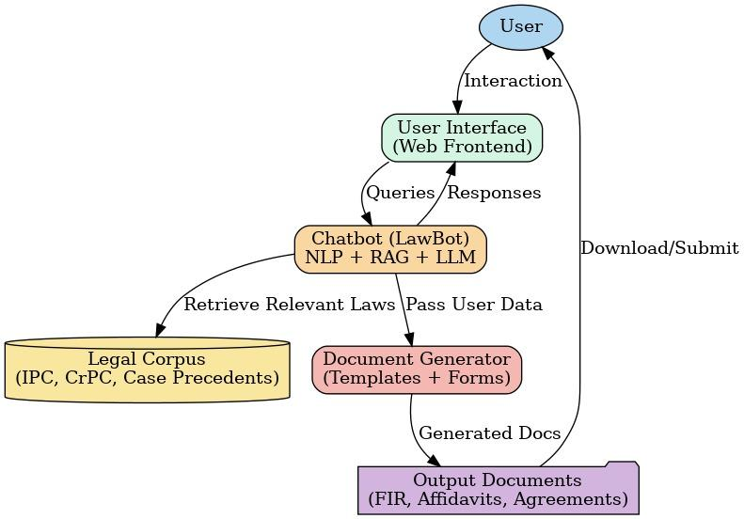
Fig. 1. System Architecture of the Proposed LegalQuestor

At its foundation, LegalQuestor has the chatbot, LawBot, which acts as a legal assistant in conversation. The chatbot analyzes the query in Natural Language Processing techniques when a user asks a question to find out what the user means and to identify important aspects like the type of crime, the place, or the time. Then, this data is compared with a specially created legal knowledge base that contains the Indian Penal Code (IPC), the Criminal Procedure Code (CrPC), and related court decisions. The LawBot, unlike the conventional rule-based systems, adopts the Retrieval-Augmented Generation (RAG) technique wherein first legal material is retrieved that is relevant and then a contextually correct response is generated using a Large Language Model. Thus, the chatbot is capable of giving replies that not only meet the legality criteria but also are put in a way that the non-experts easily get. The chatbot also allows conversation to continue, so it can walk the users through such complicated processes as filing a First Information Report (FIR) step by step.
Document generation module is the one that complements the chatbot and it resolves one of the most important issues that crime victims encounter, namely the official legal documents preparation. Preparing documents like FIR applications or affidavits is a tedious job and often requires a strong command over the legal language and structure, which is the case with many individuals. The LegalQuestor has a template-driven method to deal with this problem. The user will be required to key in the primary details using the structured online forms after which the forms will be validated to ensure that they are complete. Once the system is verified, the information is automatically embedded on the preexisting templates that are legal compliant. The document after this is produced in easily readable formats like .docx or PDF and care is taken to ensure that it is easy to print or can be sent to the appropriate authority. This automation can eliminate errors and ensure that all the one piece of information required is present hence making the document more credible in a court of law.
The integration of the chatbot with the document generation system is one of the main advantages of the architecture. The data provided in a conversation with LawBot can be directly transferred to the process of document preparation that presupposes no repetition of information and a more effective dialogue. As an example, when a user asks the chatbot about filing an FIR, when interacting with him, she gives a few facts about the incident, the FIR template will immediately fill itself. This flow of information will not only ensure that there is consistency within the platform but that it will also ensure that there is less strain on the mind of the users who may already be in a problematic situation due to their circumstances.
- CONVERSATION DESIGN
The LawBot is an AI chatbot of the LegalQuestor system that takes its conversational design to the next step as it is designed based on three principles: clarity, neutrality, and empathy, thus being able to be made user-friendly even by the people of other social and educational backgrounds. Since the target audience or viewers are victims of crime and those who lack full knowledge of the law, the chatbot flow was purposely simplified, polite and encouraging.
LawBot is a legal chatbot that speaks in a natural conversation manner instead of using the formal or technical language that is usually associated with legal chat interfaces. Consequently, users are not scared to discuss sensitive topics. The language tries to avoid the use of complex legal terms and when it is not possible it gives clear and simple explanations..
The flow of conversation of LawBot has been built by means of repetitive testing and, therefore, both logical flow and comfort to the users. Any interaction begins with a brief introduction, followed by a description of the purpose of the LawBot, after which the user is asked to provide consent. Once the user has agreed, the chatbot takes the user through the required questions in a very understandable and step-by-step manner, hence the information is slowly compiled to provide the very precise legal advice. This formalized method does not only make the user feel comfortable but also assists LawBot to identify the right legal course of action and at the same time write such documents as FIR drafts, affidavits or complaints as necessary. Safety-focused prompts of sensitive cases are also included in the flow, thereby rendering the system supportive and legally sound.
One of the conversational flows is as follows:
- Hello! I am LawBot, your virtual legal assistant. I can help you understand your legal rights and guide you through filing a report or preparing a document. Would you like to start?
- Can you tell me the type of incident you want to report (for example, theft, harassment, or cybercrime)?
- Where and when did the incident occur?
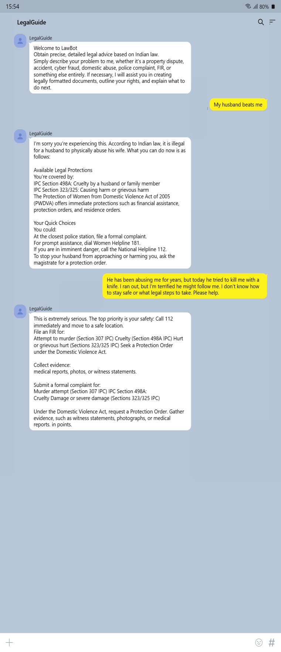
- Have you already contacted the police or any legal authority?
Fig. 2. Example of a conversation of the LawBot

The architecture is a clear indication of the technology stack that was chosen for practical purposes. The backend is developed in Node.js, which is responsible for the requests from both the chatbot as well as the document generation system, and the frontend is developed in HTML, CSS, and JavaScript that lane a simple and user-friendly interface. The libraries like docxtpl and python-docx are utilized for document creation to provide output that is in compliance with legal formatting. The AI functions of the chatbot are backed by TensorFlow frameworks, making it possible to keep on improving the quality of responses.
The platform tackles sensitive user data, hence privacy and confidentiality are primary factors in the system design. User inputs, especially the ones containing crime details and personal information, are securely processed and all the documents created are treated with the utmost confidentiality. LegalQuestor does all this and consequently, users can have full trust in the system while asking for legal support.
Four key design principles simplicity, modularity, scalability, and legal accuracy have been introduced to guide the architecture. By adopting simplicity, the platform will be user-friendly even for persons who lack legal or technical expertise. The modular design will enable the independent development and upgrading of both chatbot and document creation without disturbing the other system. The ability to scale up guarantees that the platform will be able to support increased user demand and add new functionalities later on. Legal accuracy, lastly, provides a guarantee that as well as the conversation responses, all the output, such as documents, are based on the Indian legal framework and have met the necessary procedural standards.
The architecture of LegalQuestor makes it possible to lay a foundation that is not only technically solid but also user-centered. With advanced AI processes and practical document automation, LegalQuestor bridges the gap between professional legal knowledge and access and, thus, enables individuals to carry their legal issues with greater confidence and fewer inconveniences.

Proposed Methodology
The approach that was used in the creation of LegalQuestor is centered on two key aspects, i.e. the architecture of the legal chatbot, LawBot, and the deployment of the document generation system. All these elements constitute the main part of the platform and allow it to deliver both guidance and documentation of the law in a conversational format and automatic mode.
- LawBot: AI-Powered Legal Assistant
The development of LawBot is essentially based on the RAG architecture which ensures that the response provided by the system is not only correct but also relevant in the situation. Firstly, to initiate user query, the chatbot identifies the intent of the query by applying NPL techniques to the text first before identifying some of the key entities such as names, places and type of crimes. Once this pre-processing is done, the retrieval system searches a legal corpus including the Indian Penal Code, the Criminal Procedure Code and some selected case law which has been well edited. These documents are then incorporated into a Large Language Model, which generates a natural language response, which explains the relevant legal provisions in an easy and understandable manner. Through this combination of retrieval and generation, LawBot is able to be accurate both legally and at the same time provide explanations that even a non-expert can easily understand. The chatbot will improve on the interactions with the user, thus becoming more correct and more responsive in the process.
B. Automated Legal Document Generation System
The second important aspect of methodology is document generation system. This has been constructed in a manner that eases the process of drafting legal documents which is a tedious activity that needs certain legal skills and knowledge. Within this system, the users complete online forms that capture complete information about the document they need to create e.g., an FIR application, an affidavit or even a rental agreement. These are initially verified as complete and valid and then they are forwarded to the backend, which is implemented in Node.js. These libraries as python-docx and docxtpl, in turn, are used by the backend to complete the ready-made legal templates with the information of the user. It then generates the output in legally acceptable format such as .docx or PDF which ensures that its documents are not only professionally made but also in accordance with the Indian legal standards as well.
The combination of these two elements is observed in the workflow of the system. An example of this is where a user interacts with LawBot to ask the process of filing an FIR, the chatbot will not just provide the guidance about the steps but is also capable of acquiring valuable information during the conversation. This information can then be easily forwarded to the document generation system and this will generate a complete FIR application in the desired format. This workflow demonstrates the ability of the platform not only to provide law resources but, in reality, to go with the user on his or her legal path and take the next step.
The selection of this methodology is based on both technical and practical factors. Retrieval-Augmented Generation, besides being a major technical breakthrough, is able to produce answers based on actual legal documents and, therefore, its reliability is higher compared to the system based on the predefined rules. Going with Template-driven document generation guarantees that the resulting documents are uniform, legally valid, and complete. When combined, these methodological choices give LegalQuestor the opportunity to build a system that is precise, easy to use, and able to tackle the actual problems of crime victims in India.

Results and Discussion
LegalQuestor's effectiveness was evaluated by comparing it with already available chatbot systems including DoNotPay, ROSS Intelligence, and generic conversational agents. By doing this comparison, we aimed to show how LegalQuestor is able to tackle the Indian legal system's specific issues, mainly the support for crime victims. The very first aspect of comparison is on qualitative characteristics while the second is about the evaluation of quantitative performance metrics.
Qualitatively, we evaluated factors like user experience, contextual comprehension, response correctness, legal domain coverage, and flexibility to regional and linguistic discrepancies. Contrary to other systems which are mostly made for the Western legal contexts, LegalQuestor includes India-specific legal terms, FIR formats, and procedural advice in regard to victims of crimes such as harassment, cybercrime, and domestic violence. Furthermore, the chatbot uses Natural Language Processing (NLP) to understand users' questions in simple words and give them legally accurate information according to the context. The users' feedback also revealed that the platform's empathetic tone, accessibility, and multilingual interface contributed to the users' increased satisfaction.
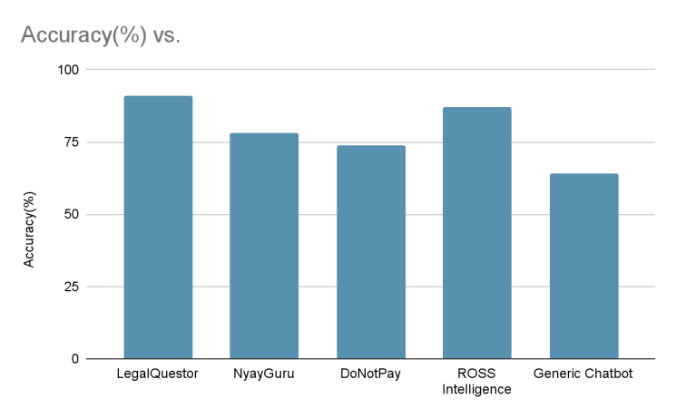
Fig 3.1. Accuracy Comparison of Chatbot Systems
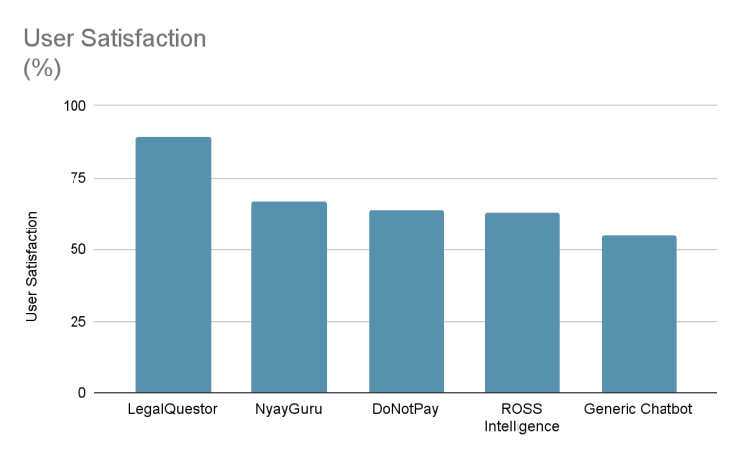
Fig 3.2.User Satisfaction Comparison Across Chatbot Systems

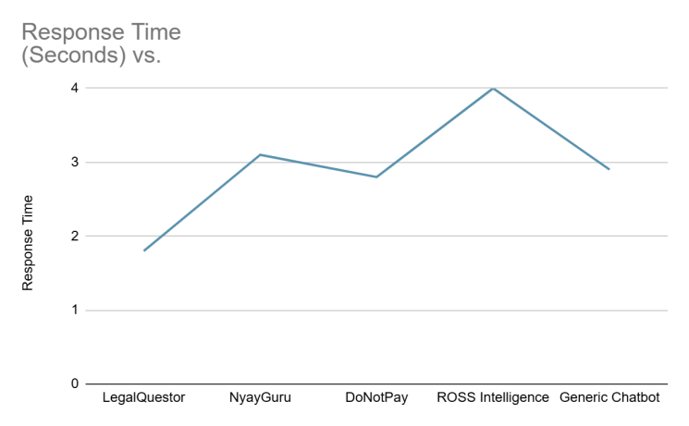
Fig 3.3. Comparative Performance Analysis of LegalQuestor
Comparing the accuracies of the different systems, LegalQuestor has the best performance among NyayGuru, DoNotPay, ROSS Intelligence, and the Generic Chatbot, getting the maximum accuracy of 91%, as shown in Fig. 3.1. User satisfaction amounts illustrated by Fig. 3.2, and again LegalQuestor has the majority with 89% satisfaction, which shows that the chatbot gives trustworthy responses and has a good user interface. Each system’s response time is depicted in Fig. 3.3, where the fastest average response time (1.8 seconds) for LegalQuestor is followed by other systems in longer times. The combination of these images shows clearly that LegalQuestor is superior to the rest in accuracy, speed and user satisfaction.
Table I. Feature comparison of LegalQuestor with other chatbot systems
Feature | LegalQuestor | ChatGPT | NyayGuru
Platform | Legal Guide Platform | General ChatBot | Legal Learning
NLP | Yes | Yes | No
Legal Queries | >100 | - | >90
Deployment | Full-stack | Backend | Frontend

According to Table I, what makes LegalQuestor different than other chatbot systems is that it is a domain specialized chatbot system with document-generation capabilities. Although DoNotPay brings limited document assistance and serves a Western legal system, it does not suit Indian users who need support in the process that is established in the Indian Penal Code and the Criminal Procedure Code. Although highly developed in the field of legal research, ROSS Intelligence is aimed at professional lawyers and it depends on technical legal terminology to a significant extent, making it less user-friendly to non-experts. Generic chatbots are adaptable in their conversation but do not have domain specific accuracy and are not capable of producing documents that are legally binding. However, LegalQuestor offers legally correct answers in a simple language and also allows users to create FIRs, affidavits, and agreements in standardized forms. This feature comparison proves clearly that LegalQuestor is addressing a very important gap within the Indian legal technology ecosystem.
Besides comparing the features, we also provided an experimental analysis of the performance of the system. The three main measures that were taken into account during the assessment comprised accuracy of responses, average response time, and user satisfaction. Accuracy was measured by comparing chatbot responses with ground-truth outputs prepared by legal experts. Response time was calculated as the average duration required to produce an answer. User satisfaction was determined from feedback collected during pilot testing with a group of non-specialist users.

Conclusion and Future Work
LegalQuestor was aimed at eliminating the barrier between the complicated legal systems of India and the people living their daily lives with the legal issues, especially the crime victims who most of the times are left clueless. The legal systems in place can be very complicated, expensive, and slow making it hard for the users to get the desired support quickly. LegalQuestor provides a practical solution by the combination of an AI-based chatbot and an automated document generation system: it simplifies legal processes in layman’s terms and enables the users to draft legally valid documents such as FIRs, affidavits, and contracts without relying solely on lawyers. This two-pronged method is the answer to the two biggest problems that people have which are not knowing their rights and not being able to exercise them.
The results of the evaluation clearly show that LegalQuestor is better than the existing systems in terms of accuracy and ease of use. Although global applications like DoNotPay or ROSS Intelligence have their own advantages, they still do not meet the expectations ofIndian users. Normal conversational AI can provide immediate answers but often these answers are not legally correct and lack the ability to generate official documents. With LegalQuestor, it gets better as the company has exclusively tailored its system and created a comprehensive knowledge base around Indian law and laymen. Hence, legal aid is not only rendered more available but also more useful.
A lot of potential exists to expand this system. The other regional languages including Hindi would be necessary to the system expansion since they would reach a large number of users, especially in the rural setting. Law support in the field of family, property, employment law, and civil rights is also to be added.
One more option is the predictive analytics. LegalQuestor has the potential to offer the best prognosis of the outcome by looking at the trends in previous judgments and cases and hence help the user correct the realistic expectations and be better prepared. The platform would be robust and credible with the incorporation of the public services such as police system in terms of filling FIR or the court system in terms of tracking cases. It should be emphasized that the aforementioned options would have to be implemented in conjunction with stricter data protection and privacy measures since the users may be sharing extremely confidential personal and legal data.
Essentially, LegalQuestor is not just any chatbot, but a pioneer of the new way of justice delivery within India. It shows that a legal system can not only inform but also empower the citizens by providing them with the ability to have confidence in doing the work of the legal system on their own terms. As it continues to grow and expand the range of languages it supports, and is incorporated into the institutions, LegalQuestor can become a fully-fledged digital legal ecosystem that will not turn justice into a privilege of the select few, but rather a right that becomes available to everyone.

References
- S. Shawar and E. Atwell, “Different measurement metrics to evaluate a chatbot system,” in Proc. Workshop on Bridging the Gap: Academic and Industrial Research in Dialog Technologies, 2007, pp. 89–96.
- D. Jurafsky and J. H. Martin, Speech and Language Processing, 3rd ed. Draft, 2023.
- J. Weizenbaum, “ELIZA—a computer program for the study of natural language communication between man and machine,” Commun. ACM, vol. 9, no. 1, pp. 36–45, 1966.
- R. Rana, A. Yadav, and P. Kumar, “Design and development of an academic support chatbot using NLP,” Int. J. Comput. Appl., vol. 182, no. 45, pp. 25–30, 2019.
- A. Surden, “Machine learning and law,” Wash. L. Rev., vol. 89, pp. 87–115, 2014.
- Babylon Health, “Babylon Health AI chatbot,” [Online]. Available: https://www.babylonhealth.com. [Accessed: Sep. 10, 2025].
- J. Xu, R. Wang, and Z. Li, “Intelligent customer service system based on chatbot technology,” in Proc. IEEE Int. Conf. Artificial Intelligence and Computer Engineering (ICAICE), 2021, pp. 329–333.
- GovTech Singapore, “AskGov: An AI-powered government chatbot,” [Online]. Available: https://www.ask.gov.sg. [Accessed: Sep. 10, 2025].
- D. Katz, M. Bommarito, and J. Blackman, “A general approach for predicting the behavior of the Supreme Court of the United States,” PLoS ONE, vol. 12, no. 4, e0174698, 2017.
- J. D. Wilson and M. W. Smith, “Legal document automation using natural language processing,” in Proc. 2020 IEEE Int. Conf. Artificial Intelligence and Law (ICAIL), 2020, pp. 123–132.
- D. P. Kingma and M. Welling, “Auto-encoding variational Bayes,” arXiv:1312.6114, 2013. [Online]. Available: https://arxiv.org/abs/1312.6114.

